

**Summer Newsletter**

**You are all invited to the Dogwise Summer Party!!**

**Come and meet the staff and enjoy an afternoon of tea & cake**

**27th July 3pm-5pm**

**Dogwise Training School**

**Drop in without your dogs and meet the team**

**Reunite yourself with people you have not seen in a while ☺**

The weather is getting warm!

It is so important to walk our dog before it gets to warm and to keep them cool

Providing mental stimulation through, food puzzles or scentwork games can tire them out if you have a dog that needs to be busy

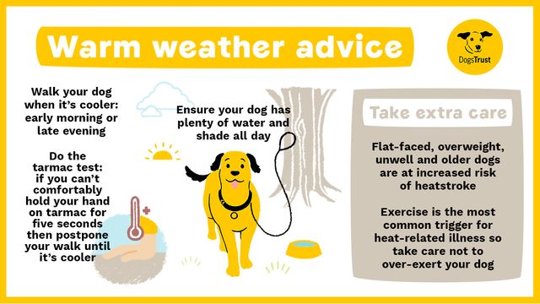

**Workshops**

**Puppy Scentwork**

4 week course starting 9th July. Introducing your puppy to a whole new world of sniffing and fun!

9th - 30th July Start - 6pm Cost for the block £68

Suitable for puppies that are fully vaccinated up to 9months old.

Looking at how to teach your puppy to find their favorite toy or food in a safe environment, whilst building up confidence.

**Longline Handlings**

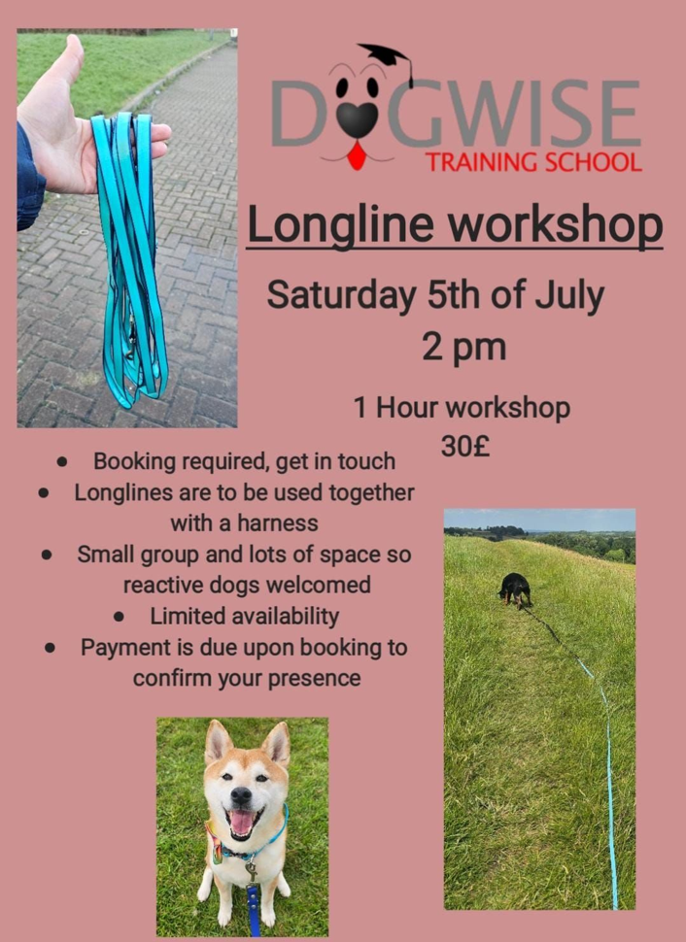5th July 2pm - £30  
Learn how to use a longline in harmony without getting tangled up!  
Come along to this fantastic workshop and find out the uses of a longline.

**Fitpaws**

Fitpaws canine conditioning workshops last 30mins and a great way to keep your dog fit and healthy. 121 sessions booking is required through Faye £20 for 30mins.

**Hoopers**

In September 4 week course costing £80

4th, 11th, 18th & 25th

5pm-6pm Thursday evenings

Suitable for beginners - small class no more than 5 dogs

Want to have individual sessions on

**Hoopers at a time that suits you?**

**Dog Sports 121 at £35 per hour**

**Tracking**

These sessions can be done as a Sports 121 – 1hour at £35 or once you have done a starter session you can join the monthly club at £30 a session. – Contact Faye for more details.

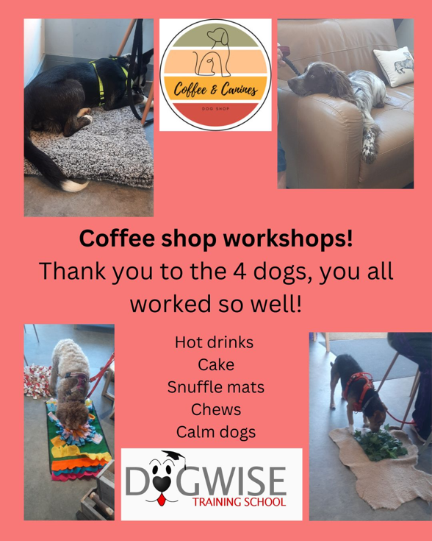

**Trick Training**

22nd July 18:15 - £30

9th August 14:00 - £30

23rd September 18:15 - £30

**Coffee & Canine – Gillingham Dorset**

21st July 17:00-18:00 & 18:00-19:00

20th August 17:00-18:00 & 18:00-19:00

£15 per session a max of 4 dogs in each session

All workshops and classes require pre-booking and payment before your first session.

**121 Training Sessions**

Do you feel you need more guidance with your training, or is your dog displaying some worrying behavior? 121 training sessions maybe for you.

£95 field training

£95 for home visits

Traveling to you outside of our area is an additional cost.

**121 Sports Sessions**

121 sports sessions are a great way to see if your dog enjoys the sports, before you commit to a block booking.

£35 for 1hour at Dogwise

(£30 – for Premium Members)

Contact your trainer to book yourself in!

Like all classes, 121’s are pre-booked and payment is required beforehand to confirm your booking.

**Upcoming shows**

Gillingham & Shaftesbury Show 13th & 14th August

We are always looking out for more helpers or if you wish to come along to a display with your dog – please let your trainer know

**Pack walks in 2025**

7th September

5th October

2nd November

7th December

Please note due to the length of walks, it is not suitable for dogs under the age of 1.

Meet at Dogwise for 10am – donations to charity welcome.

**Join our Premium Membership scheme in 2025! Save money on your classes and use of the Dogwise field on Sundays as well as discounts emailed out frequently!**

[**https://www.dogwisetraining.net/mere/membership-scheme/**](https://www.dogwisetraining.net/mere/membership-scheme/)

**Please note the last day of training 13th December and we reopen 6th January 2026**

**We would like to say thank you to everyone that recommends Dogwise on social media or in public.**

**If you wish to not receive these emails – please email back and we shall take you off our mailing list – Thank you**

**www.dogwisetraining.net**