

**Spring Newsletter**

**Our charity this year is**



All our Pack Walks, tombola’s and fun dog shows will raise money for this small charity. To find out more please see their website -

<https://www.petbloodbankuk.org/>

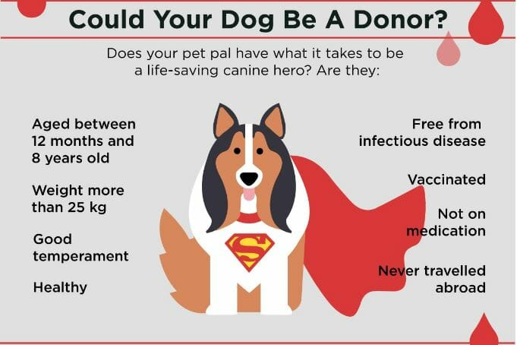

**New classes starting in March!**

**Agility**

Tuesdays 10am & 11am

**Gundog**

Thurdays 10am

**Scentwork**

Thurdays 11am

Message on Facebook or mobile 07807 486377 or EMAIL ME info@dogwisetraining.net

For details on how to join these amazing classes

We will only allow 5 dog in a class

Classes are 1 hour long

**Workshops**

**Fitpaws**

Fitpaws canine conditioning workshops last 30mins and a great way to keep your dog fit and healthy. 121 sessions booking is required through Faye £20 for 30mins.

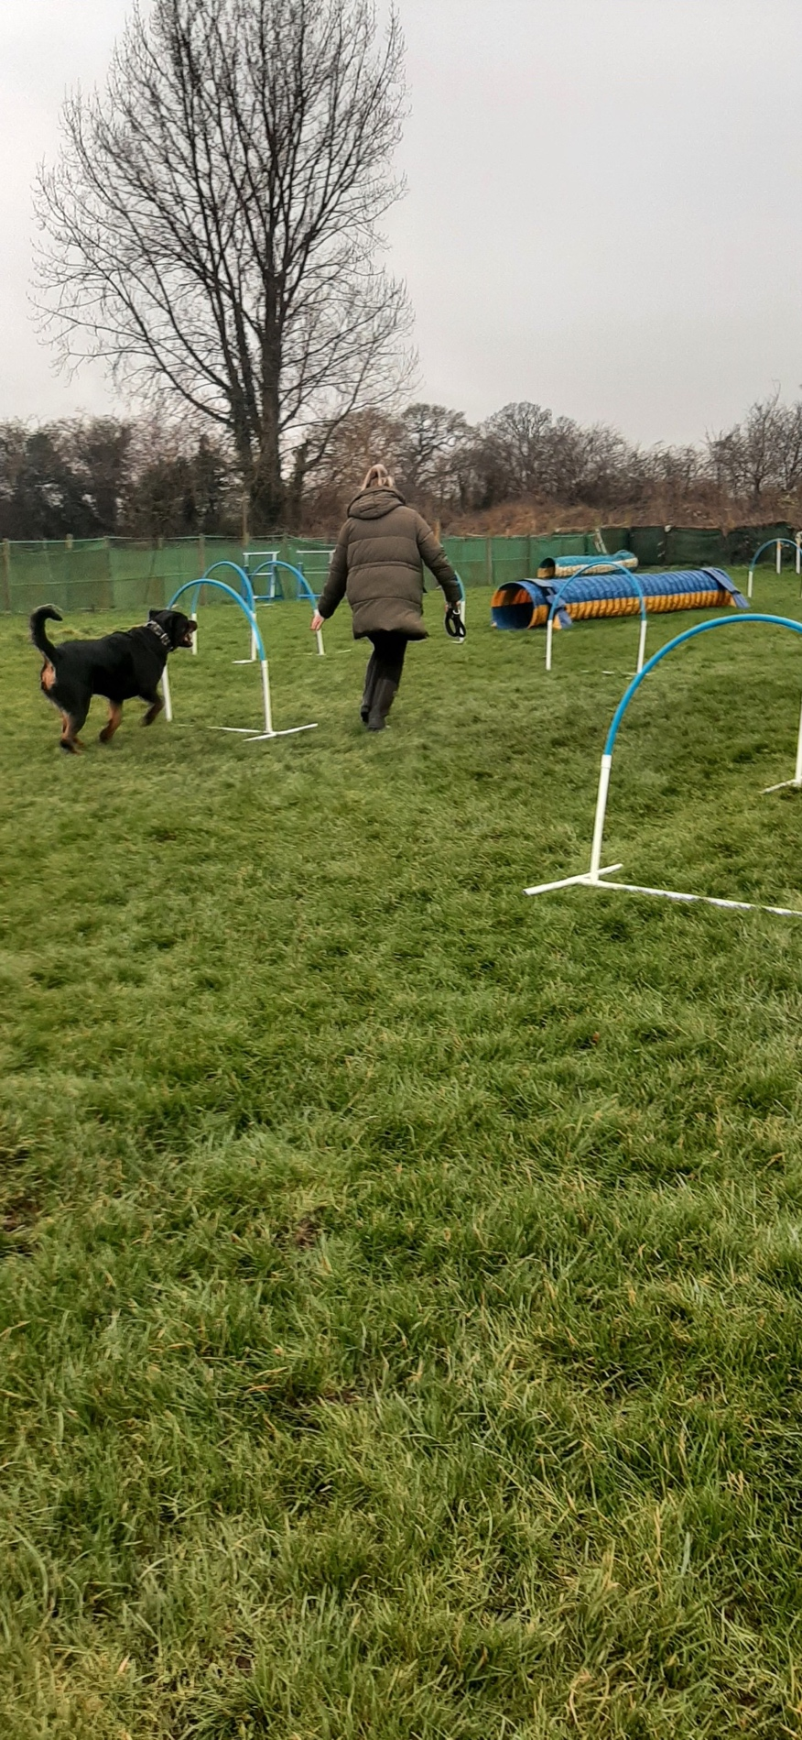

**Hoopers**

In April 4 week course costing £90

3rd, 10th, 17th & 24th

5pm-6pm Thursday evenings

Suitable for beginners - small class no more than 5 dogs

Want to have individual sessions on **Hoopers at a time that suits you?**

**Dog Sports 121 at £35 per hour**

**Tracking**

These sessions can be done as a Sports 121 – 1hour at £35 or once you have done a starter session you can join the monthly club at £30 a session. – Contact Faye for more details.

**Treibbal**

Fun herding ball games – think football but for dogs!

10th May 2pm - £30

17th June 18:15pm - £30

12th July 2pm - £30

**Trick Training**

22nd March 2pm - £30

6th May 6:15pm - £30

3rd June 18:15 - £30

**UK Dog Sports**

A multi-disciplined sport

9th May 7pm - £30

6th June 7pm - £30

All workshops and classes require pre-booking and payment before your first session.

**121 training sessions**

Do you feel you need more guidance with your training, or is your dog displaying some worrying behavior? 121 training sessions maybe for you.

£95 field training

£95 for home visits

Traveling to you outside of our area is an additional cost.

**121 sports sessions**

121 sports sessions are a great way to see if your dog enjoys the sports, before you commit to a block booking.

£35 for 1hour at Dogwise

(£30 – for Premium Members)

Contact your trainer to book yourself in!

Like all classes, 121’s are pre-booked and payment is required beforehand to confirm your booking.

**Upcoming shows**

Dorset Spring Show 3rd & 4th May

Gillingham & Shaftesbury Show 13th & 14th August

We are always looking out for more helpers or if you wish to come along to a display with your dog – please let your trainer know

**Pack walks in 2025**

2nd March – 10am

6th April – 10am

11th May -10am

1st June – 10am

Please note due to the length of walks, it is not suitable for dogs under the age of 1.

Meet at Dogwise for 10am – donations to charity welcome.

**Join our Premium Membership scheme in 2025! Save money on your classes and use of the Dogwise field on Sundays as well as discounts emailed out frequently!**

[**https://www.dogwisetraining.net/mere/membership-scheme/**](https://www.dogwisetraining.net/mere/membership-scheme/)

**We would like to say thank you to everyone that recommends Dogwise on social media or in public.**

**If you wish to not receive these emails – please email back and we shall take you off our mailing list – Thank you**

**www.dogwisetraining.net**

