

**Winter Newsletter**

**Dogwise’s last day of training is Saturday 14th Decemeber reopening week 6th January 2025!**

**We raised £437.50**

**Thank you everyone!!!**



Thank you to everyone for all the donations from the Pack Walks, charity tombola and fun dog shows. As well as those misshapes in the agility rings!

They help owners, vets and pets navigate all the information surround cancer. They increase awareness of pet cancers and how it can be diagnosed and treated.

To find out more please see their website below.

<https://www.animalcancertrustcharity.co.uk/>

Of course, and physical donations like leads and unopened food will still be donated to Happy Landings in Shepton Mallet. Happy Landings have been so thankful to the coats and bowls plus very thing else everyone has donated throughout the year.

**Ways to keep our pets safe during these colder months**

* Shave/cut the hair between your dog’s pads – keeping the hair short will help prevent ice and grit sticking to the hair.
* Wash their paws after a walk if you – especially if there has been salt on the roads. And afterward apply a paw balm, to stop the pads splitting.
* Dog coats! Some breeds of dogs are more sensitive to the temperature change and a coat on walks can help them feel more at ease. You may also find wearing a thin coat on in the house also helps your dog.
* Food try not to over feed your dog during the winter months, you may not be doing the same levels of exercise as you were doing in the Summer months.
* Know what foods are safe for your dogs to eat, with Christmas around the corner you do not want any unwanted vet visits.

Please see the Blue Cross website for more information about what food your dog can eat.

<https://www.bluecross.org.uk/advice/dog/christmas-dangers-for-dogs>

**How to make a Paw Balm**

Of course, there are lots on the market and ready to use paw balms.

However if you have these ingredients and a jar you can make your own!

You will need Shea butter, Coconut butter and if you wish beeswax. Make to a ratio of 2:2:2 and then melt in a saucepan and pour into a jar or pot.

**Workshops**

**In the spring we will be hosting more workshops!**

**UK Dog Sports, Hoopers and Trick Training**

**Fitpaws**

Fitpaws canine conditioning workshops last 30mins and a great way to keep your dog fit and healthy. 121 sessions booking is required through Faye £20 for 30mins.

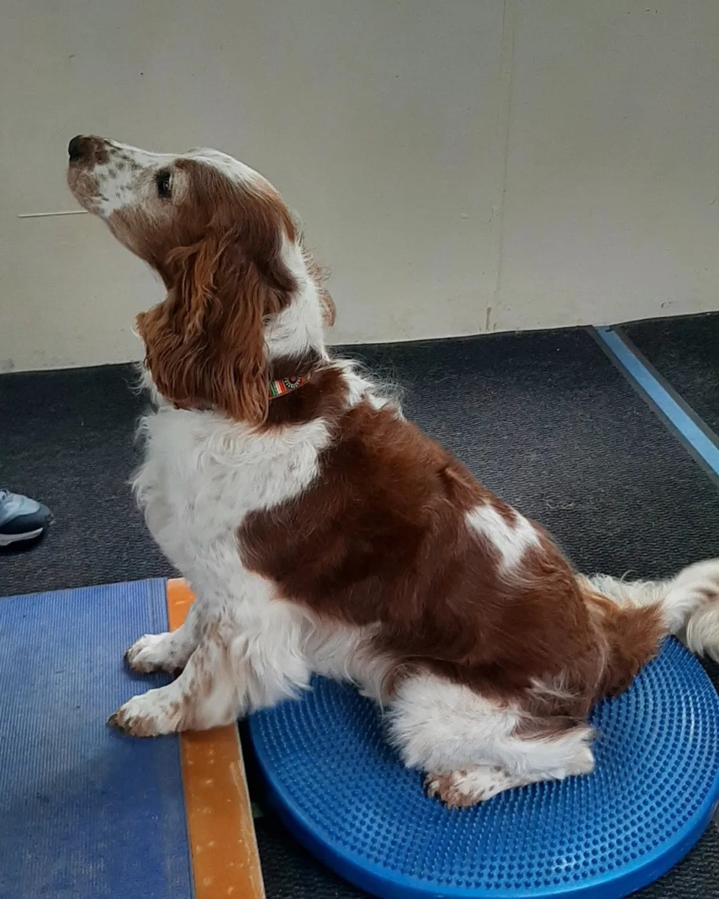

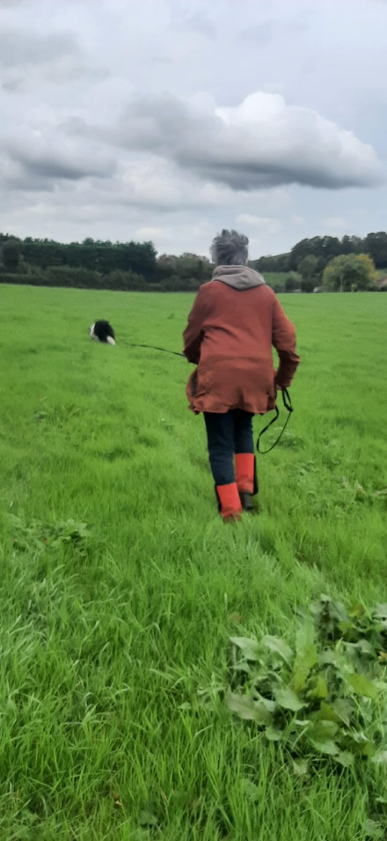

**Tracking Club!**

We have had a great start to our tracking club in 2024, if you wish to find out more and get your dog started on this sport please contact Faye.

We will be running a monthly get-together and enjoy the use of your dog’s nose!

If you notice on walks your dog’s nose is on the floor – following a scent they can do tracking! Any age of dog and any breed of dog can do tracking.

You will need a Y shaped harness and a longline (you can borrow one from us and of course we sell them in the shop)

New beginners sessions starting in February 2025 – keep an eye out on Facebook and the shop information board.

**121 training sessions**

Do you feel you need more guidance with your training, or is your dog displaying some worrying behavior? 121 training sessions maybe for you.

£85 field training

£95 for home visits

Traveling to you outside of our area is an additional cost.

**121 sports sessions**

121 sports sessions are a great way to see if your dog enjoys the sports, before you commit to a block booking.

£35 for 1hour at Dogwise

(£30 – for Premium Members)

Contact your trainer to book yourself in!

Like all classes, 121’s are pre-booked and payment is required beforehand to confirm your booking.

**Pack walks in 2025**

12th January – 10am

2nd Feburary – 10am

2nd March – 10am

6th April – 10am

Please note due to the length of walks, it is not suitable for dogs under the age of 1.

Meet at Dogwise for 10am – donations to charity welcome.

**Join our Premium Membership scheme in 2025! Save money on your classes and use of the Dogwise field on Sundays as well as discounts emailed out frequently!**

[**https://www.dogwisetraining.net/mere/membership-scheme/**](https://www.dogwisetraining.net/mere/membership-scheme/)

**We would like to say thank you to everyone that recommends Dogwise on social media or in public.**

**Have a lovely Winter and we shall see you in the New Year!**

